**GROUP 13**

|  |  |  |
| --- | --- | --- |
| **UFID** | **NAME** | **EMAIL** |
| 98831646 | MAYANK SHARMA | mayanksharma@ufl.edu |
| 80659919 | ISWARYA SUBBURAJ | iswarya.subburaj@ufl.edu |
| 01794985 | JAYETRI BARDHAN | jayetri.bardhan@ufl.edu |
| 85550520 | SIDDHARTH GUPTA | siddhartgupta@ufl.edu |

**INTERNATIONAL HEALTH AND POPULATION MATRICS APPLICATION**

**Table of Content**

ER-Diagram 2

Relational Schema: 2

SQL Table Schemas 3

# **ER-Diagram**

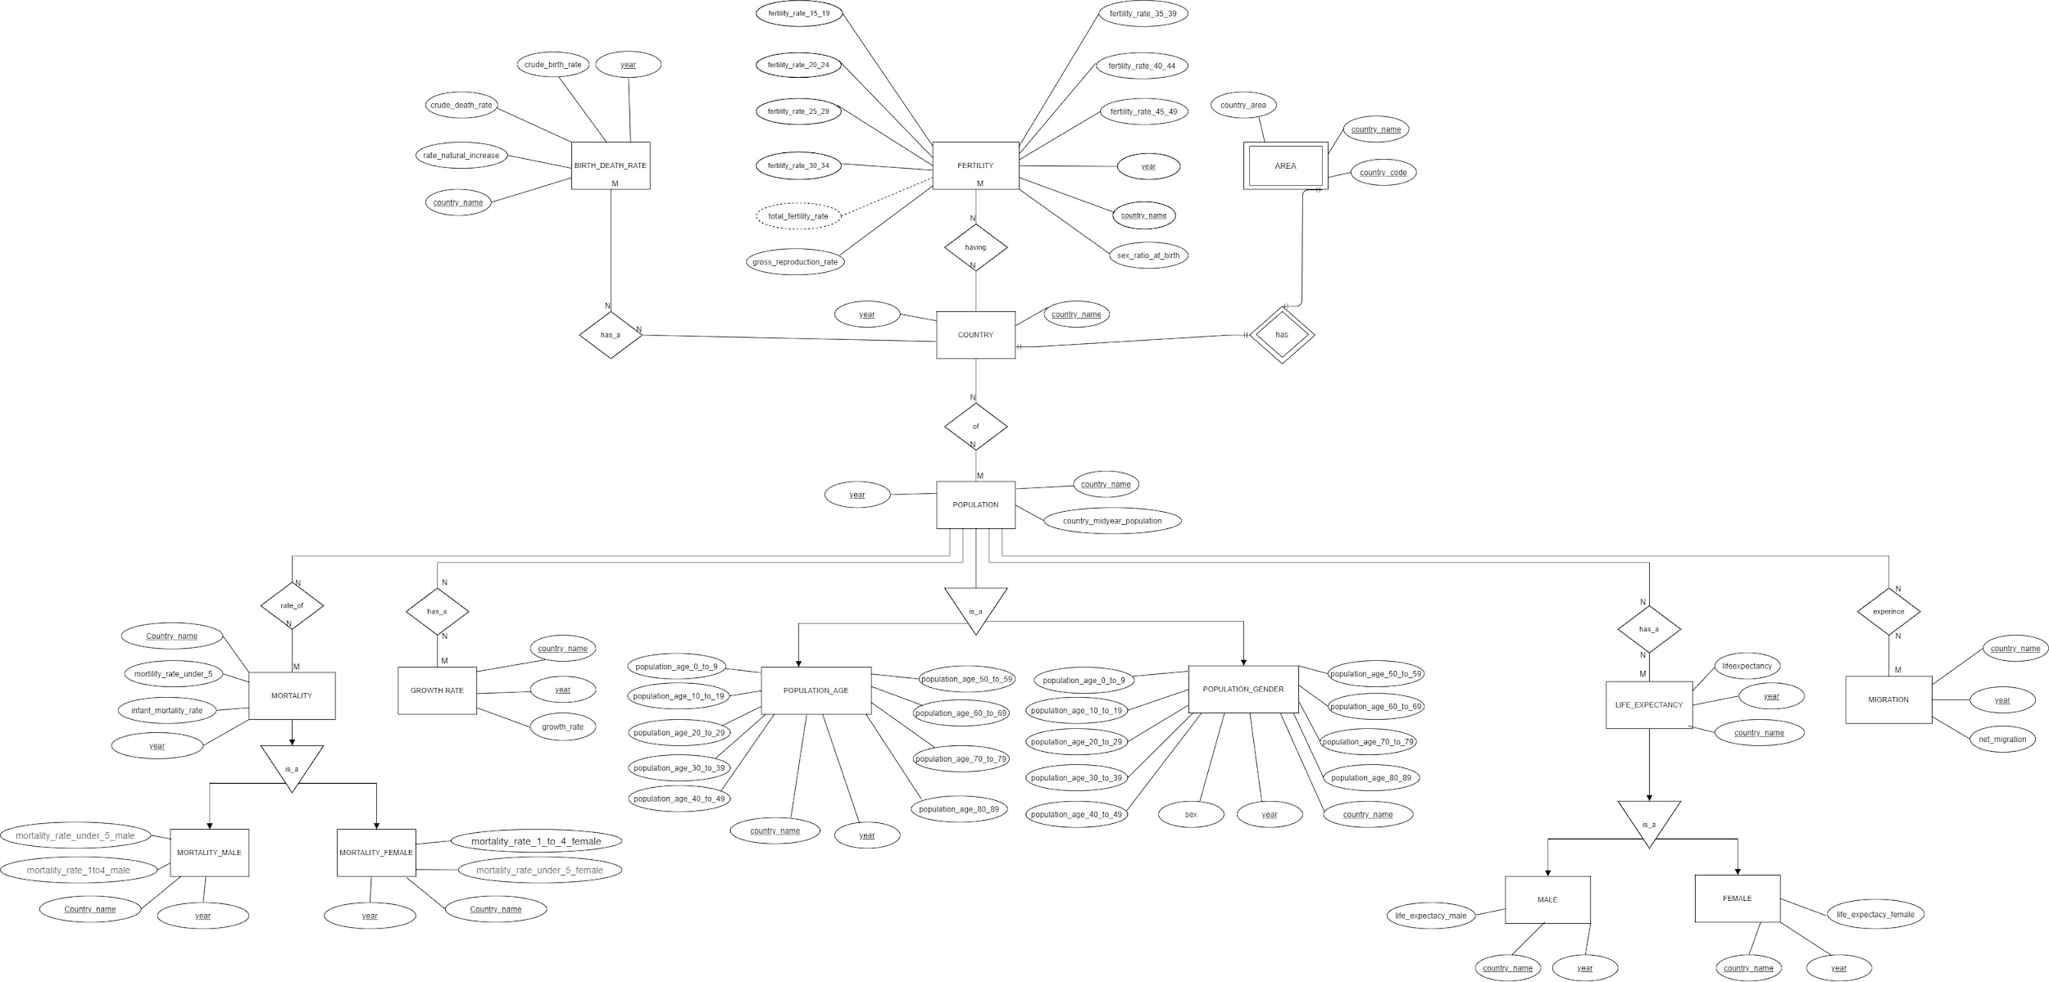

# **Relational Schema:**

* Population_age(Country_name:String,year:Integer,Population_age_0_to_9:Integer, Population_age_10_to_19:Integer,Population_age_20_to_29:Integer,Population_age_30_to_39:Integer,Population_age_40_to_49:Integer,Population_age_50_to_59:Integer,Population_age_60_to_69:Integer,Population_age_70_to_79:Integer,Population_age_80_to_89:Integer)
* Population_gender(Sex:String,Year:integer,country_name:String,Population_age_0_to_9:Integer,Population_age_10_to_19:Integer,Population_age_20_to_29:Integer,Population_age_30_to_39:Integer,Population_age_40_to_49:Integer,Population_age_50_to_59:Integer,Population_age_60_to_69:Integer,Population_age_70_to_79:Integer,Population_age_80_to_89:Integer)
* Population(Country_name:String,year:Integer,country_midyear_population: Integer)
* Country(Country_code: String,Country_name:String,year:Integer)
* Area(Country_code: String, Country_name:String,year:Integer,country_area:Float)
* Migration( Country_name:String,year:integer,Net_Migration:Float)
* LifeExpectancy(Country_name:String,year:Integer,Life_Expectancy:float)
* Mortality(Country_name:String,year:Integer,mortality_rate_under_5:Float,infant_mortality_rate:Float)
* Mortality_male(Country_name:String,year:Integer,mortality_rate_under_5_male:Float,mortality_rate_1to4_male: Float)
* Mortality_female(Country_name:String,year:Integer,mortality_rate_under_5_female: Float, mortality_rate_1to4_female:Float)
* GrowthRate(Country_name:String,year:Integer,Growth_rate:Float)
* Birth_death_rate(Country_name:String,year:Integer,crude_birth_rate:Float,crude_death_rate:Float, rate_natural_increase:Float)
* Fertility(Country_name:String, year:Integer, sex_ratio_at_birth:Float, fertility_rate_15_19:

Float, fertility_rate_20_24:Float, fertility_rate_25_29:Float, fertility_rate_30_34:Float, fertility_rate_35_39:Float, fertility_rate_40_44:Float, fertility_rate_45_49:Float)

* Male(country_name: String, year:Integer, life_expectancy_male: Float)
* Female(country_name: String, year:Integer, life_expectancy_female: Float)

# **SQL Table Schemas**

* Birth_death_rate(Country_name:String,year:Integer,crude_birth_rate:Float,crude_death_rate:Float, rate_natural_increase:Float)

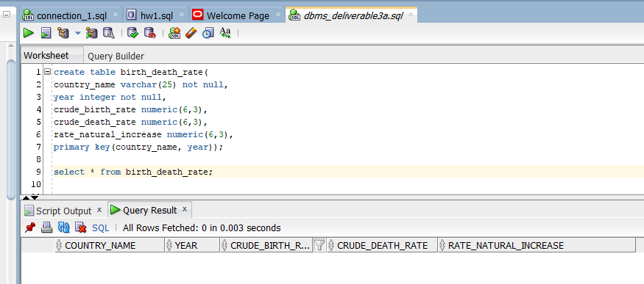

* Fertility(Country_name:String, year:Integer, sex_ratio_at_birth:Float, fertility_rate_15_19:

Float, fertility_rate_20_24:Float, fertility_rate_25_29:Float, fertility_rate_30_34:Float, fertility_rate_35_39:Float, fertility_rate_40_44:Float, fertility_rate_45_49:Float)

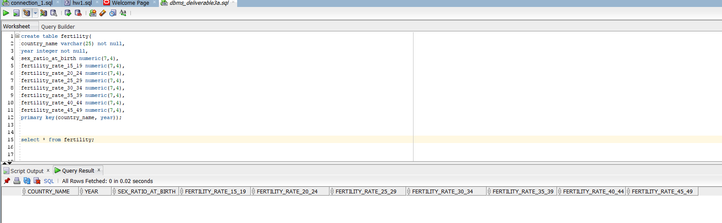

* Country(Country_code: String,Country_name:String,year:Integer)

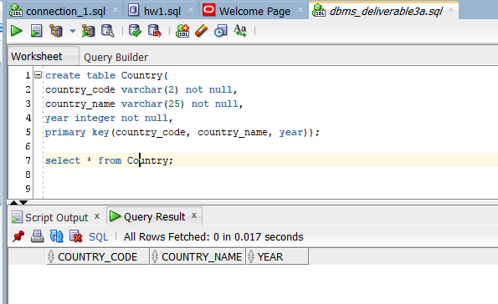

* Population(Country_name:String,year:Integer,country_midyear_population: Integer)

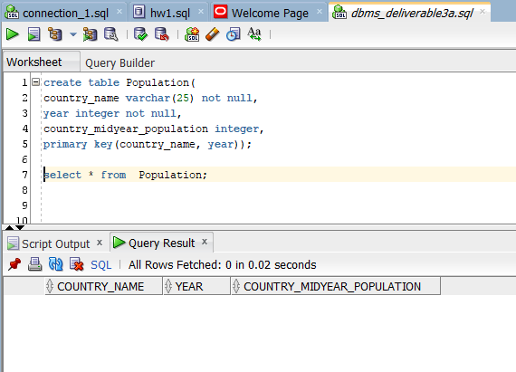

* Area(Country_code:String,Country_name:String,year:Integer,country_area: Float)

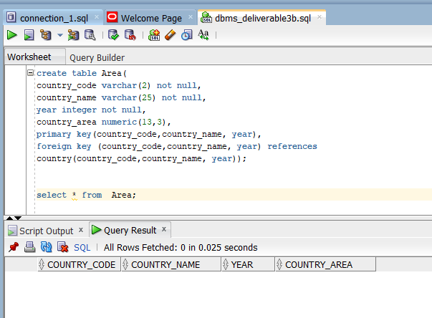

* Mortality(Country_name:String,year:Integer,mortality_rate_under_5:Float,infant_mortality_rate:Float)

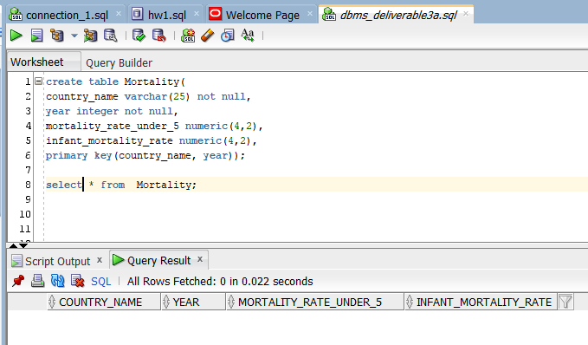

* Mortality_male(Country_name:String,year:Integer,mortality_rate_under_5_male:Float,mortality_rate_1to4_male:Float)

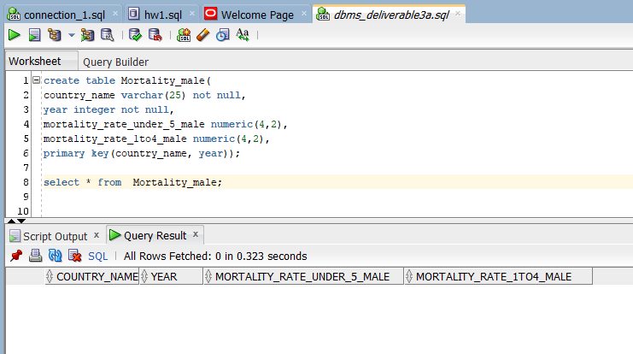

* Mortality_female(Country_name:String,year:Integer,mortality_rate_under_5_female: Float, mortality_rate_1to4_female:Float)

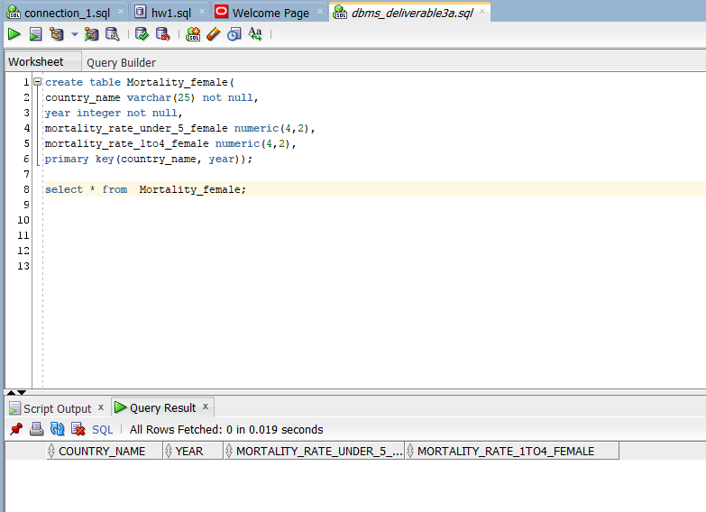

* GrowthRate(Country_name:String,year:Integer,Growth_rate:Float)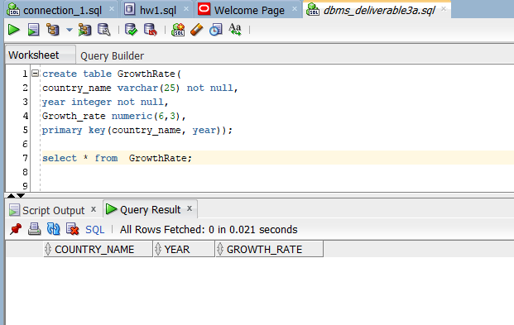
* Population_age(Country_name:String,year:Integer,Population_age_0_to_9:Integer,poPopulation_age_10_to_19:Integer,Population_age_20_to_29:Integer,Population_age_30_to_39:Integer,Population_age_40_to_49:Integer,Population_age_50_to_59:Integer,Population_age_60_to_69:Integer,Population_age_70_to_79:Integer,Population_age_80_to_89:Integer)

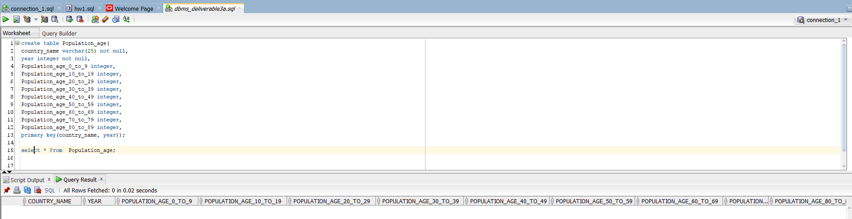

* Population_gender(country_name:String,Year:integer,Sex:String,Population_age_0_to_9:Integer,Population_age_10_to_19:Integer,Population_age_20_to_29:Integer,Population_age_30_to_39:Integer,Population_age_40_to_49:Integer,Population_age_50_to_59:Integer,Population_age_60_to_69:Integer,Population_age_70_to_79:Integer,Population_age_80_to_89:Integer)

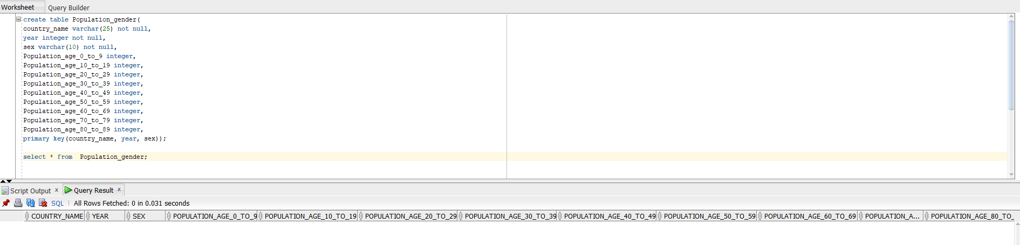

* LifeExpectancy(Country_name:String,year:Integer,Life_Expectancy:float)

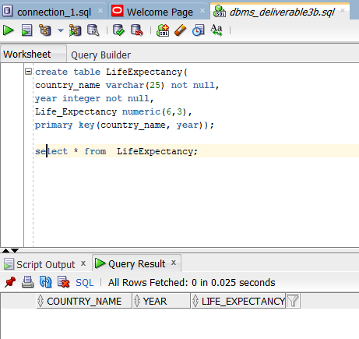

* Male(country_name: String, year:Integer, life_expectancy_male: Float)

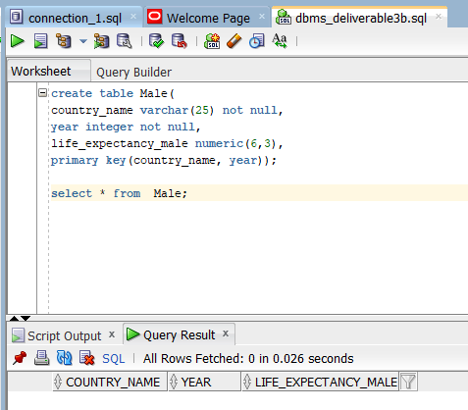

* Female(country_name: String, year:Integer, life_expectancy_female: Float)

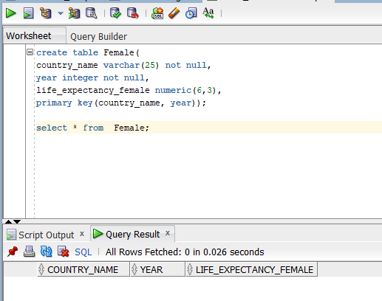

* Migration( Country_name:String,year:integer,Net_Migration:Float)

